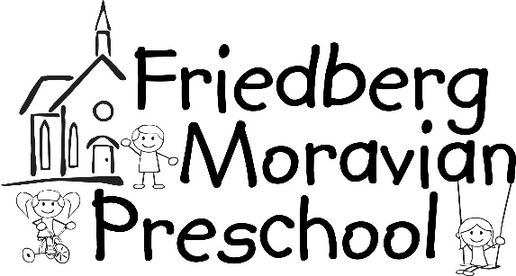
Date __________

Reg fee___________
_____Accept letter
_____ August letter

2178 Friedberg Church Road Winston-Salem, NC 27127 (336)764-1840 www.fmpreschool.com

2024-2025 Registration
Please check desired class.

Twos: 2 days/week… $185/month Tuesday & Thursday _____
(Must be 2 by 8/31/23)

Two’s: 3 days/week… $225/month Monday, Wednesday, Friday______

Three’s: 3 days/week… $225/month Tuesday, Wednesday, Thursday _____
(Must be three by 8/31/23)

3 days/week…. $225/month Monday, Wednesday, Friday _____

PreK: 4 days/week… $255/month Monday – Thursday _____
(Must be four by 8/31/23)

5 days/week… $285/month Monday – Friday _____

Classes are 8:30-11:30 * Optional Lunch Bunch 11:30-12:30 *

Friedberg Moravian Preschool follows the age guidelines set by the NC Board of Education requiring children to be the class age on or before August 31 of the year they enter. For example, children enrolled for the 2024-25 three year old class must be age three on or before August 31, 2024.

A non-refundable $90 per child or $150 per family (2 or more children) registration fee is required with application. Make checks payable to Friedberg Moravian Preschool.

Child’s Name_______________________________________________________________________
First Middle Last Preferred Name
Date of Birth________________________ Primary Phone__________________________________
________________________________________________________________________________
Street City State Zip Code
County_______________________email_______________________________________________
Mother’s Name_____________________________________ Cell #_________________________
Employer________________________________________ Wk.#__________________________
Father’s Name______________________________________Cell#__________________________
Employer________________________________________Wk#__________________________

Parent’s Marital Status: Married______ Single_____ Separated_____ Divorced_____
Please let the Director know of any special custody arrangements or restrictions. Please provide a copy of any legal documents that pertain to the safety and well-being of your child.

Siblings & Ages: _______________________________________________________________
Church affiliation________________ Would you like information about Friedberg Moravian Church?________
Emergency Contacts (other than parents):
1. Name________________________________________Relation_________________
Home Phone ____________________Cell Phone_______________________
2. Name________________________________________Relation_________________
Home Phone ____________________Cell Phone_______________________
Allergies:___________________________ Medications:____________________________________
Medical Conditions:_________________________________________________________________
Child’s Doctor: ____________________________________Phone___________________________
Address________________________________________________________________________
A current medical and immunization record is required each year and can be updated at any time but must be current the first day of school 2023.

Field Trip Permission

______I/We give permission for my/our child to attend field trips planned by Friedberg Moravian Preschool. I will provide an approved child safety seat for my child and I give staff members permission to secure my child in the seat. We have one whole school field trip in October and parents are invited to attend.

Playground and Play Equipment Policy

______I/We give permission for my/our child to participate in all supervised and scheduled activities during the normal operation of a school day. I have seen the playground and inside play equipment. I understand that the staff will use proper safety procedures and precautions to ensure the safety of my child.

Photo Permission
______I/We give permission for my/our child’s photographs to be used (without name) on the teacher’s private site. I understand that photographs will be used only in the Photo Album sections and as highlights on the Home and information pages and cannot be downloaded. Teachers may have private blogs or Facebook pages that you will have access to but cannot be viewed by the public.

Return registration form and fee in your child’s backpack, hand to the director/teacher or place in the outside Drop Box. Additional forms are available in the preschool office, outside information box or at www.fmpreschool.com. Make payments by cash or check payable to Friedberg Moravian Preschool.

